https://ssl.gstatic.com/ui/v1/icons/mail/profile_mask2.png  
[https://ci6.googleusercontent.com/proxy/184hAkpqVA4HmxrB2p8Q1LP2y47j6dQCwDyrq5KJiegIpB4YDqBnZ0pDAdmXDbiXG-QqqYLYdDUBUN7p2QqI83gtgOD7fXvR=s0-d-e1-ft#https://smartinternz.com/assets/logo/smartinternz.png](https://smartinternz.com/)

Dear Student,

Greetings from Smartinternz,

You have successfully joined a team. Please find your team details below:

**Team ID :** LTVIP2023TMID11579

**Team Size :** 4

**Team Leader :** N KARTHIK

**Team member :** S MOHAN

**Team member :** N PUNEETH KUMAR

**Team member :** K BALACHANDRA

### Creation Of Semester Object For Candidate Internal Result Card

1. Click on the gear icon and then select Setup.

2. Click on the object manager tab just beside the home tab.

3. After the above steps, have a look on the extreme right you will find a Create Dropdownclick on that and select Custom Object.

4. On the Custom Object Definition page, create the object as follows:

5. Label: Semester

6. Plural Label: Semesters

7. Record Name: Semester Name

8. Check the Allow Reports

9. Check the Allow Search

10.Click Save.

In the same way create **4**more objects as **Candidate**, **Course Details**, **Lecturer Details** and **Internal results**.

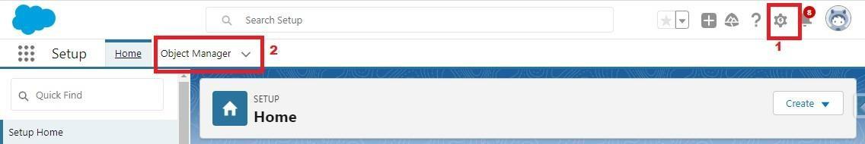

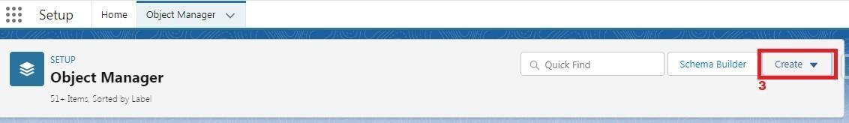

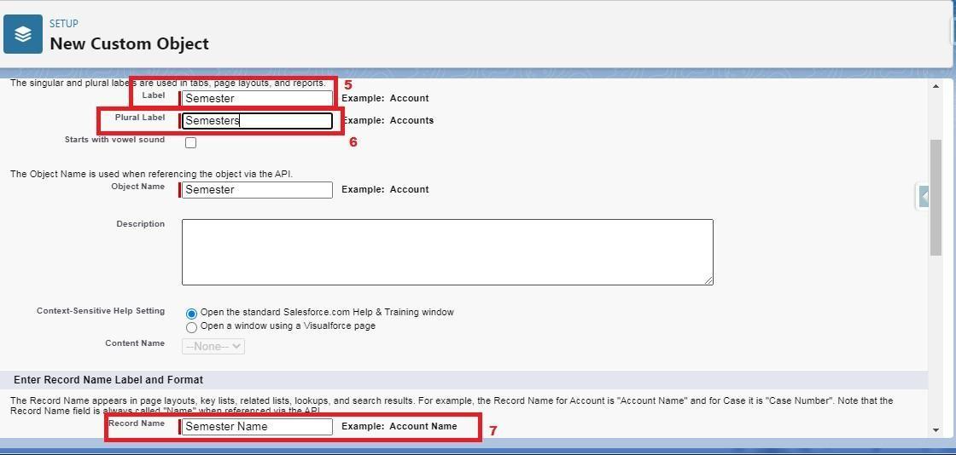

**Creation Of Semester Tab For Candidate Internal Result Card**

Now create a custom tab. Click the Home tab.

1. Enter Tabs in Quick Find and select Tabs.

2. Under Custom Object Tabs, click New.

3. For Object, select Semester.

4. For Tab Style, select any icon.

5. Leave all defaults as is. Click Next, Next, and Save

6. In the same way create Tabs for all Custom Objects -Candidate, Course Details, Lecturer Details, Internal results .

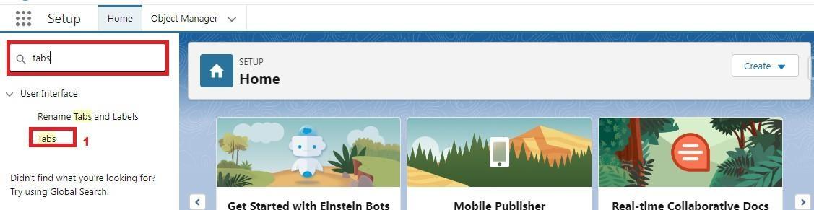

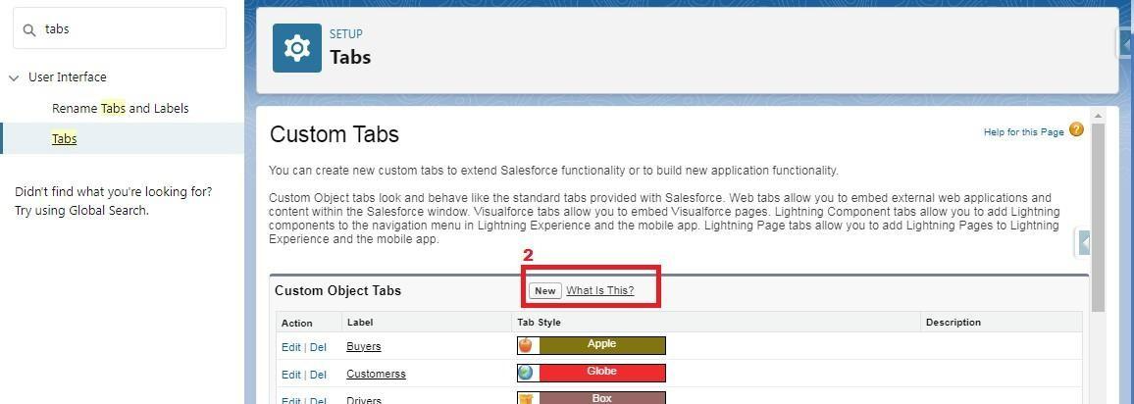

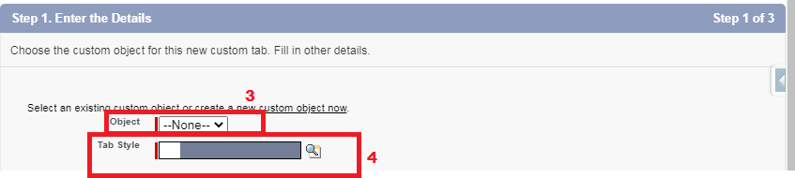

**Create The Candidate Internal Result Card App**

1. From Setup, enter App Manager in the Quick Find and select App Manager.

2. Click New Lightning App.

3. Enter **Candidate Internal Result Card** as the App Name, then click next

4. Under App Options, leave the default selections and click next.

5. Under Utility Items, leave as is and click Next.

6. From Available Items, select **Semester**, **Candidate**, **Course Details**, **Lecturer Details**, **Internalresults**, **Reports**, and **Dashboards** and move them to Selected Items.

7. Click Next.

From Available Profiles, select System Administrator and move it to Selected Profiles. Click Save & Finish.

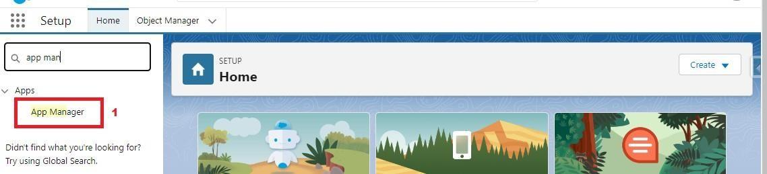

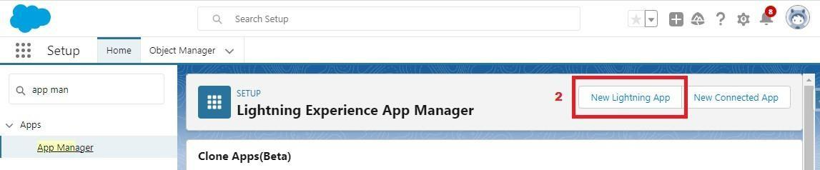

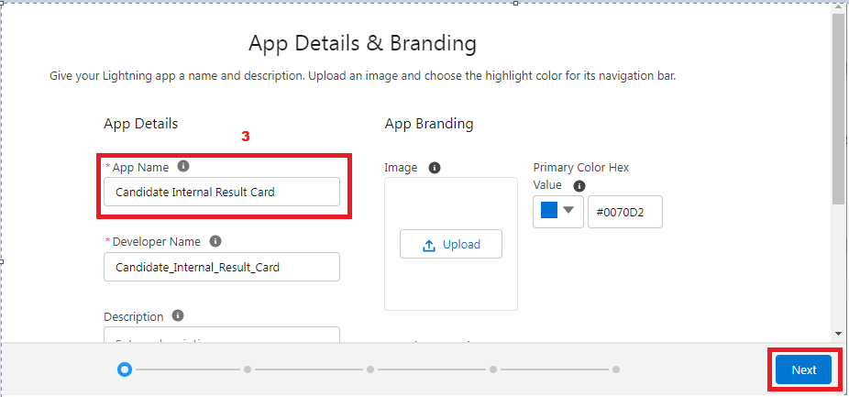

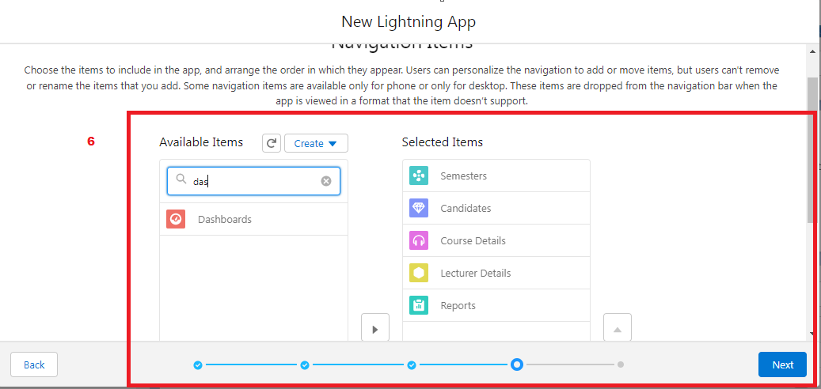

**Creation Of Text Field On "Lecturer Details" & Look Up Field For The “Candidate” Object**

1.Click the gear icon and select Setup. This launches Setup in a new tab.

2. Click the Object Manager tab next to Home.

3. Select Lecturer Details

4. Select Fields & Relationships from the left navigation

5. Click New

6. Select the Text as the Data Type, click next.

7. For Field Label, enter Lecturer Role

8. Enter Length 40

9. Click Next, Next, then Save & New.

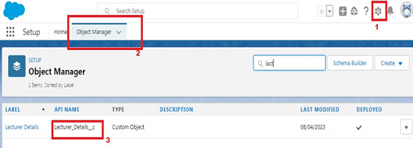

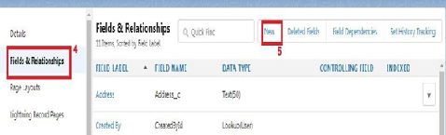

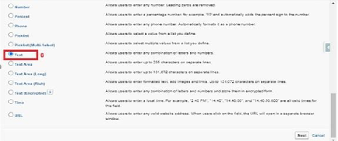

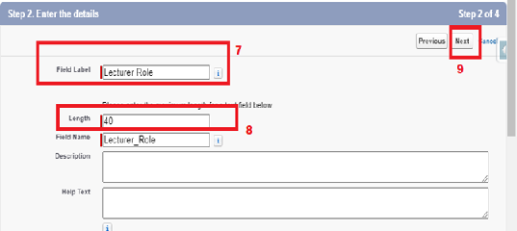

Now Let’s create a Lookup field on candidate object

1. Click the gear icon and select Setup. This launches Setup in a new tab.

2. Click the Object Manager tab next to Home.

3. Select candidate.

4. Select Fields & Relationships from the left navigation

5. Click New

6. Select the lookup as the Data Type, then click Next.

7. In related select Semester

8. For Field Label Semester Name, enter.

9. Click Next, Next, then Save & New.





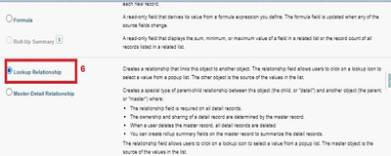

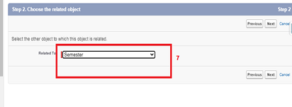

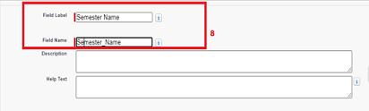

Note- Similarly create all lookup fields on their respective objects.

**Creation Of Auto Number Field On Candidate Object, Number Field On Course Details Object & Formula Field Course Details Object**

Let’s create a Number field on Course Details object

1. Click the gear icon and select Setup. This launches Setup in a new tab.

2. Click the Object Manager tab next to Home.

3. Select Course Detail.

4. Select Fields & Relationships from the left navigation

4. Click New & select number field, click Next

6. For Field Label Duration, enter.

7. Give Help Text- Enter Course duration value in Years

8. Click Next, Next, then Save & New.





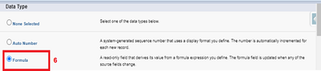

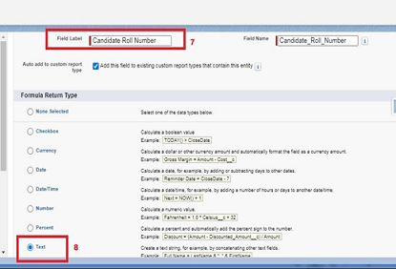

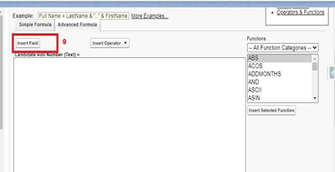

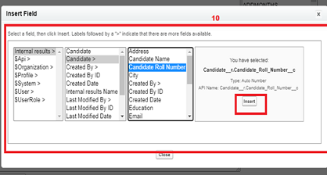

Now Let’s create an auto number field on Candidate object

1. Click the gear icon and select Setup. This launches Setup in a new tab.

2. Click the Object Manager tab next to Home.

3. Select Candidate.

4. Select Fields & Relationships from the left navigation

5. Click New

6. Select the Auto Number as the Data Type, then click Next.

7. For Field Label Candidate enter Roll Number.

8. Give a display format

9. Click Next, Next, then Save & New.





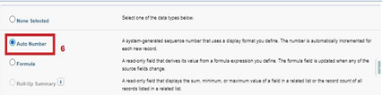

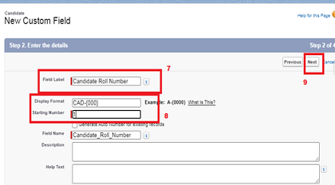

**Creation Of Auto Number Field On Candidate Object, Number Field On Course Details Object & Formula Field Course Details Object**

Let’s create a Number field on Course Details object

1. Click the gear icon and select Setup. This launches Setup in a new tab.

2. Click the Object Manager tab next to Home.

3. Select Course Detail.

4. Select Fields & Relationships from the left navigation

4. Click New & select number field, click Next

6. For Field Label Duration, enter.

7. Give Help Text- Enter Course duration value in Years

8. Click Next, Next, then Save & New.





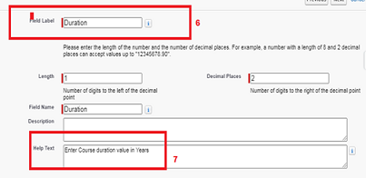

Now Let’s create a Formula field on Internal Results object

1. Click the gear icon and select Setup. This launches Setup in a new tab.

2. Click the Object Manager tab next to Home.

3. Select Internal results.

4. Select Fields & Relationships from the left navigation.

5. Click New

6. Select the Formula as the Data Type, then click Next.

7. Give field label Candidate Roll Number

8. Select formula return type text, Click Next

9. Click Insert Field

10.Create and insert formula Candidate r.Candidate_Roll_Number   c, and then click Insert.

11.Click Next, Next, then Save.













Now Let’s create an auto number field on Candidate object

1. Click the gear icon and select Setup. This launches Setup in a new tab.

2. Click the Object Manager tab next to Home.

3. Select Candidate.

4. Select Fields & Relationships from the left navigation

5. Click New

6. Select the Auto Number as the Data Type, then click Next.

7. For Field Label Candidate enter Roll Number.

8. Give a display format

9. Click Next, Next, then Save & New.









**Creation Of Auto Number Field On Candidate Object, Number Field On Course Details Object & Formula Field Course Details Object**

Let’s create a Number field on Course Details object

1. Click the gear icon and select Setup. This launches Setup in a new tab.

2. Click the Object Manager tab next to Home.

3. Select Course Detail.

4. Select Fields & Relationships from the left navigation

4. Click New & select number field, click Next

6. For Field Label Duration, enter.

7. Give Help Text- Enter Course duration value in Years

8. Click Next, Next, then Save & New.







Now Let’s create a Formula field on Internal Results object

1. Click the gear icon and select Setup. This launches Setup in a new tab.

2. Click the Object Manager tab next to Home.

3. Select Internal results.

4. Select Fields & Relationships from the left navigation.

5. Click New

6. Select the Formula as the Data Type, then click Next.

7. Give field label Candidate Roll Number

8. Select formula return type text, Click Next

9. Click Insert Field

10.Create and insert formula Candidate r.Candidate_Roll_Number   c, and then click Insert.

11.Click Next, Next, then Save.













Now Let’s create an auto number field on Candidate object

1. Click the gear icon and select Setup. This launches Setup in a new tab.

2. Click the Object Manager tab next to Home.

3. Select Candidate.

4. Select Fields & Relationships from the left navigation

5. Click New

6. Select the Auto Number as the Data Type, then click Next.

7. For Field Label Candidate enter Roll Number.

8. Give a display format

9. Click Next, Next, then Save & New.









**Creation Of Auto Number Field On Candidate Object, Number Field On Course Details Object & Formula Field Course Details Object**

Let’s create a Number field on Course Details object

1. Click the gear icon and select Setup. This launches Setup in a new tab.

2. Click the Object Manager tab next to Home.

3. Select Course Detail.

4. Select Fields & Relationships from the left navigation

4. Click New & select number field, click Next

6. For Field Label Duration, enter.

7. Give Help Text- Enter Course duration value in Years

8. Click Next, Next, then Save & New.

Now Let’s create a Formula field on Internal Results object

1. Click the gear icon and select Setup. This launches Setup in a new tab.

2. Click the Object Manager tab next to Home.

3. Select Internal results.

4. Select Fields & Relationships from the left navigation.

5. Click New

6. Select the Formula as the Data Type, then click Next.

7. Give field label Candidate Roll Number

8. Select formula return type text, Click Next

9. Click Insert Field

10.Create and insert formula Candidate r.Candidate_Roll_Number   c, and then click Insert.

11.Click Next, Next, then Save.









Now Let’s create an auto number field on Candidate object

1. Click the gear icon and select Setup. This launches Setup in a new tab.

2. Click the Object Manager tab next to Home.

3. Select Candidate.

4. Select Fields & Relationships from the left navigation

5. Click New

6. Select the Auto Number as the Data Type, then click Next.

7. For Field Label Candidate enter Roll Number.

8. Give a display format

9. Click Next, Next, then Save & New.



**Delete Record (Course Details)**

Deleting Records of Course Details Object

1. Click on App Launcher on left side of screen.

2. Search Candidate Internal Result Card & click on it.

3. Click on Course details Tab.

4. Click on Arrow at right hand side on that Particular record.

5. Click delete and delete again.

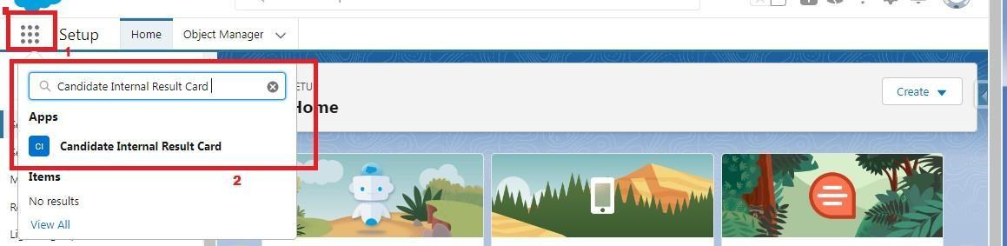

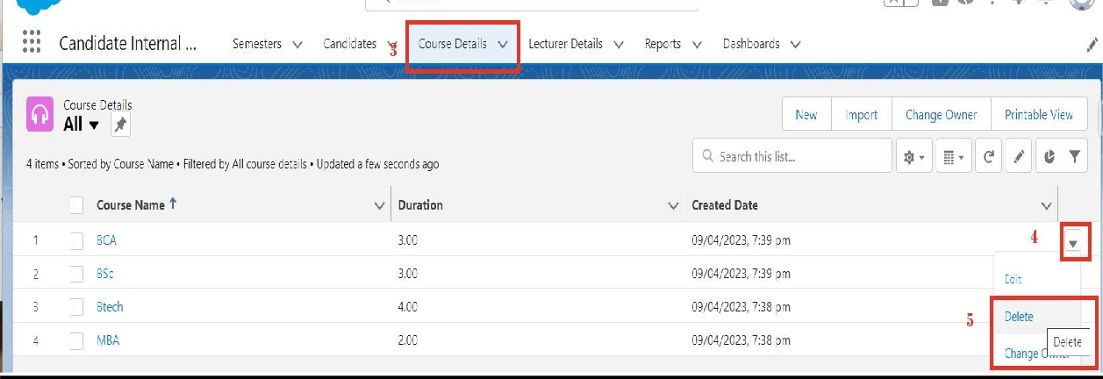

**Create Report**

1. Click App Launcher

2. Select Candidate Internal Result Card App

3. Click reports tab

4. Click New Report.

5. Click the report type as Semesters with Course Click Start report.

6. Customize your report, in group rows select - Course Name, in group column Select Duration (In this way we are making a Matrix Report).

7. Click refresh

8. Click save and run

9. Give report name – Candidate Internal Result Report

10.Click Save

NOTE: In this report you can see your all record of the object you selected for reporting (What you Selects in “Select a report type option”).

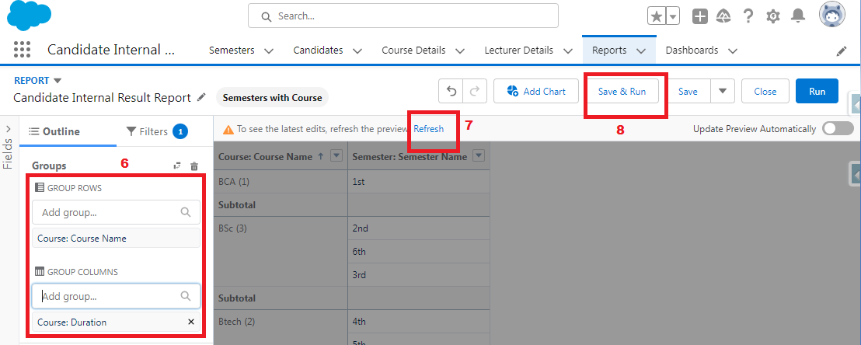

1.    On the report builder page, locate the "Fields" pane on the left-hand side.

2.    Find the field for which you want to create a bucket field and drag it to the report preview section.

3.    Click on the field in the report preview to open the field properties.

4.    In the field properties, locate the "Summarize" option and click the drop-down arrow.

5.    Select "Bucket Field" from the available options.

6.    In the bucket field settings, define the buckets based on your requirements. You can specify the bucket ranges, labels, and groupings.

7.    Click "OK" or "Apply" to save the bucket field settings.

8.    Customize the report layout and add any additional fields or filters as needed.

9.    Once you are satisfied with the report setup, click "Save" to save the report.

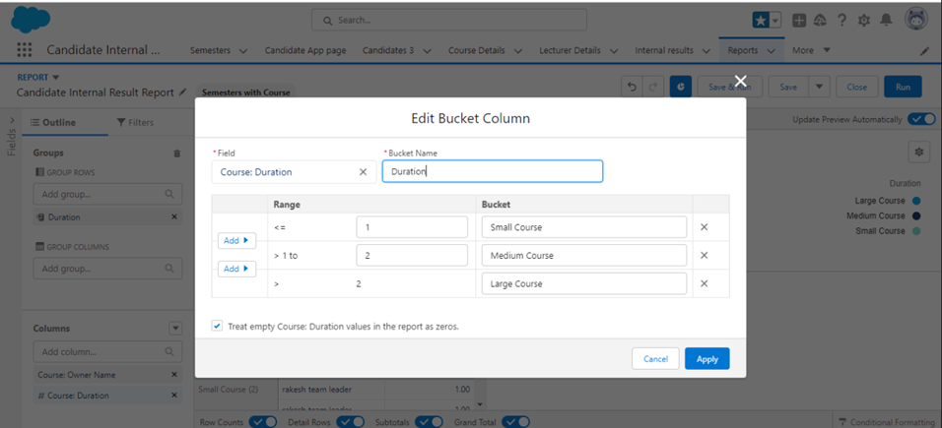

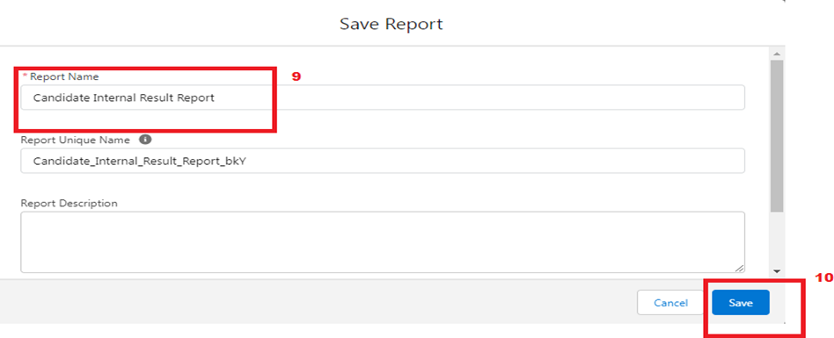

**View Report**

1. Click on App Launcher on left side of screen.

2. Search Candidate Internal Result Card App & click on it.

3. Click on Reports Tab.

4. Click on Candidate Internal Result Report and see records.



### fgshgrwfsdfvc.pngCreate Dashboard

1. Click on Dashboards tab from the Candidate Internal Result Card application.

2. Click on new dashboard.

3. Give name- Candidate Internal Result Card

4. Click create

5.  Give your dashboard a name and click on +component

6. Select the Candidate Internal Result Report which you created.

7. For the data visualization select any of the chart, table etc. as per your choice/requirement.

8. Click add.

9. Click save.­­­­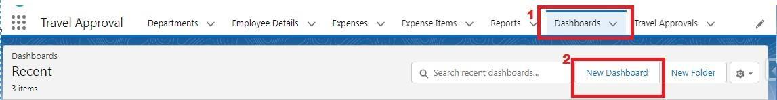

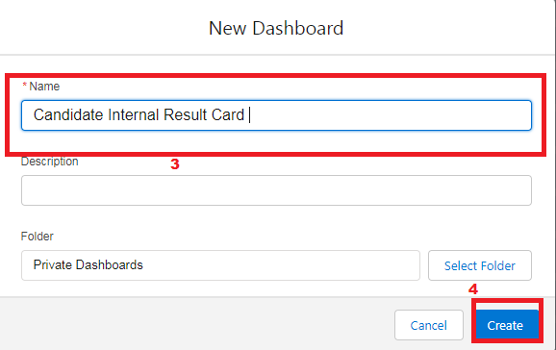

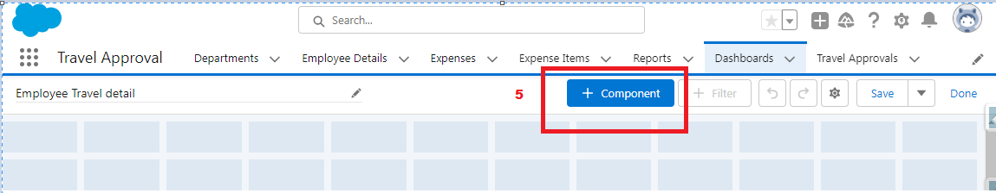

### dfsab fdvbfda.pngView Dashboard

1. Click on App Launcher on left side of screen.

2. Search Candidate Internal Result Card & click on it.

3. Click on Dashboard Tab.

4. Click on Candidate Internal Result Card see graph view of records



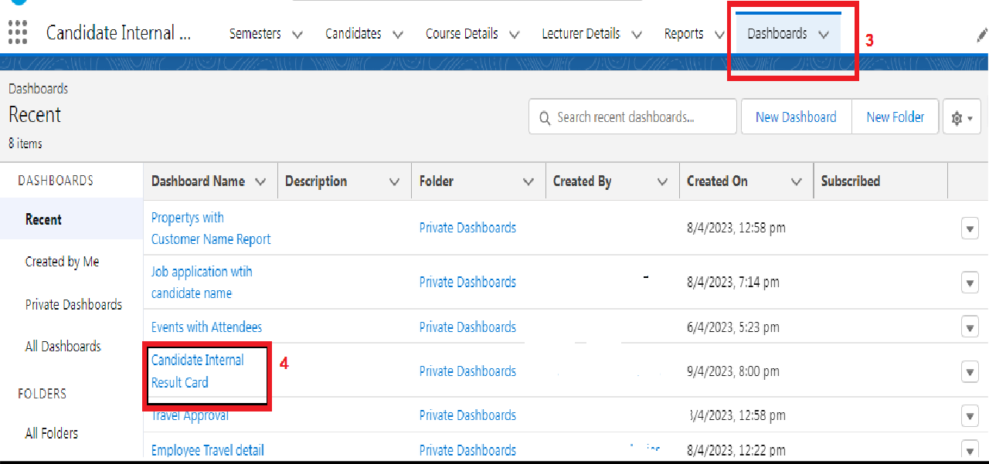

**Create A Screen Flow**

1. Click on Gear icon and select setup

2. In Quick find Box enter flow and select the flows

3.Click on New flow and Select Screen flow

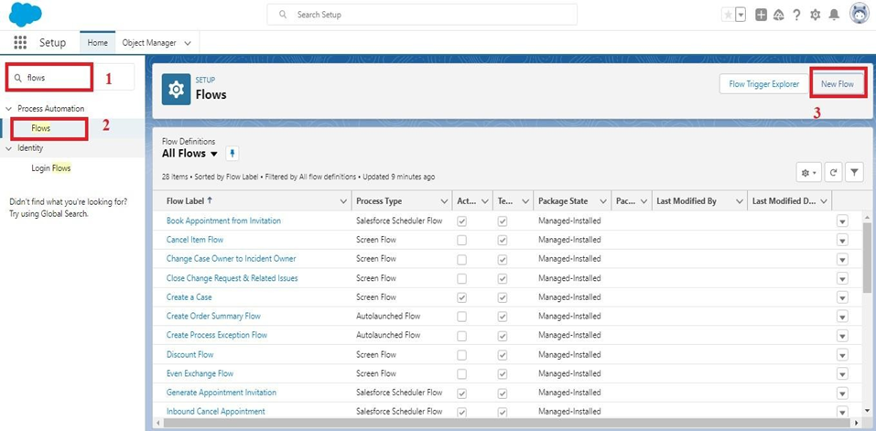

4.It will open the canvas. Select (+)

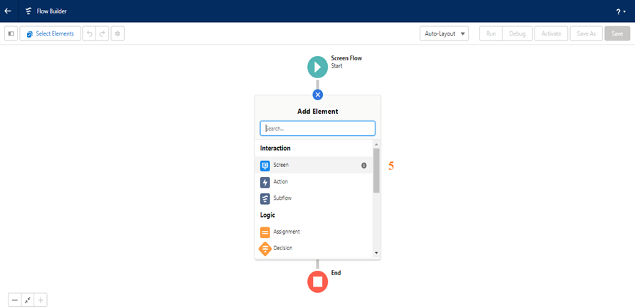

5.Select the screen element from the drop down.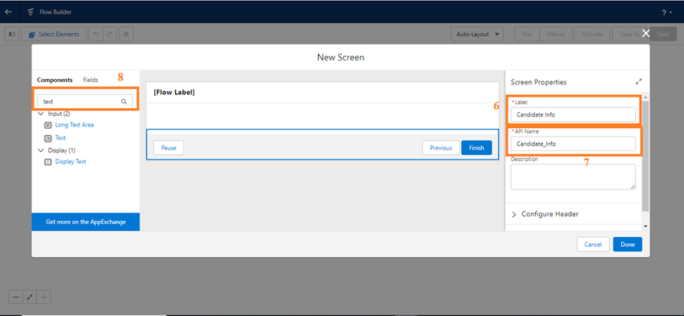

6.It will open the dialog box. Now give the label name and api name will be auto populated. These labels are for your screen Element.

     Label: Candidate info

     API Name: Candidate_Info (This field will be auto populated.)

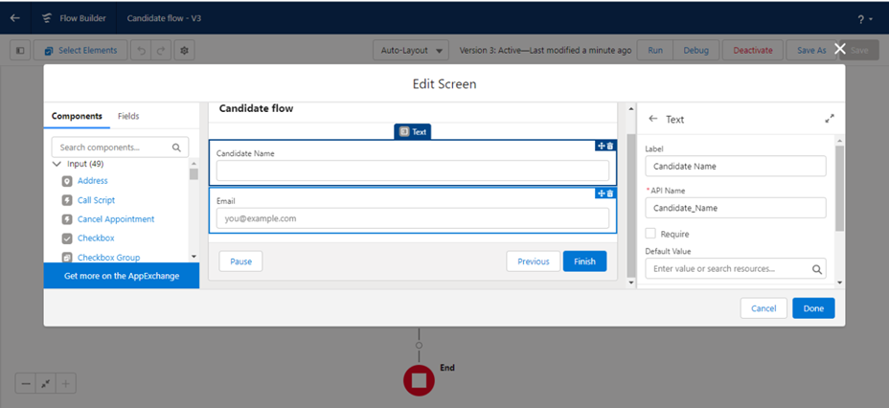     7..In search Component type text and drag the text component to canva and give the label and Api Name

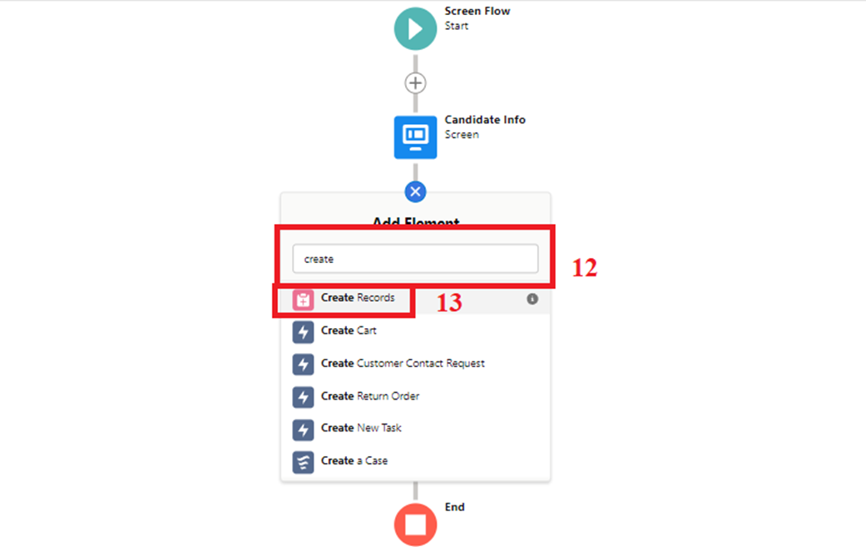

8.   8.Similarly, Add Email Component also.

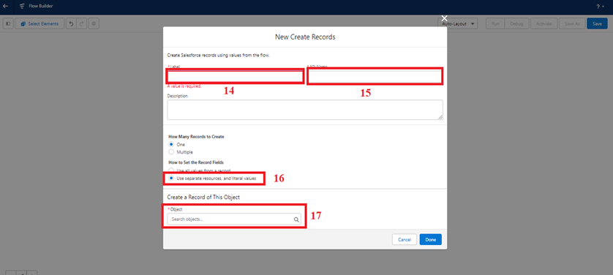    19.Enable Subject and Give Welcome

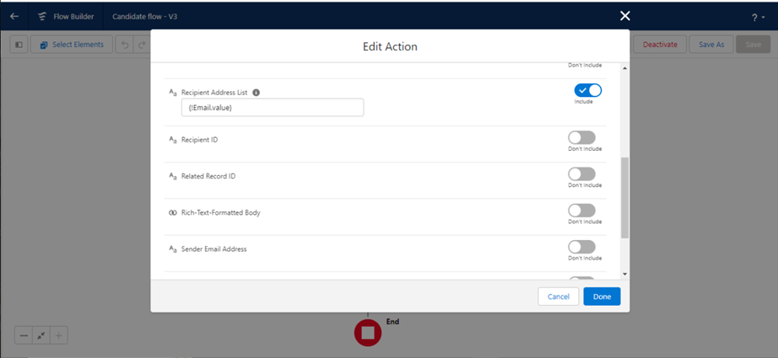Flow label: Candidate flow

      Flow API Name: Candidate_flow (this will be auto populated)

     20.Click on save

     21.Click on the Activate.

### xxxxxx.png

**Create An App Page**

1. Click on the Gear icon and select set up.

2. In Quick Find Box . Type app Builder and select the lighting app builder

3. Select New

### zzzzz.png

### 4.Select the App page and click on Next

### cccc.png

5. Give the label Name.

Label Name: Candidate App page.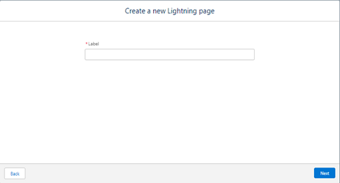   
6. Select the one region and click on finish.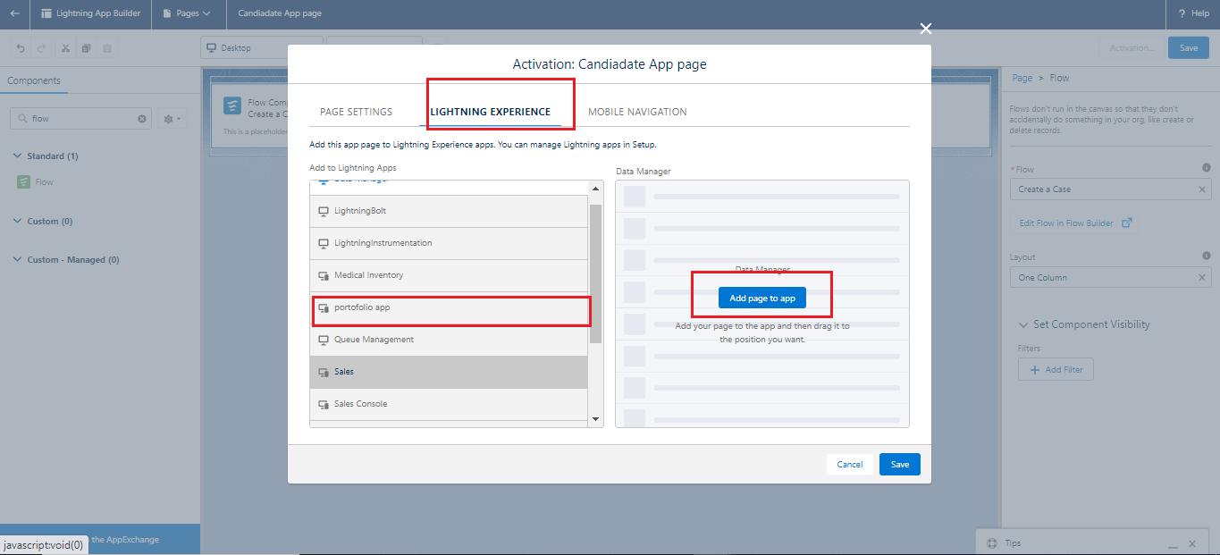   
7. Type the flow in the search bar and select the flow component and drag the component to the Add components here.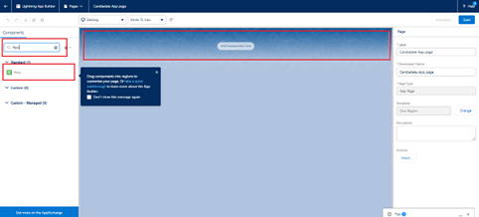

8. After dragging the component, give the flow label in the flow search and then click on save and then click on activate. Flow label:Candidate flow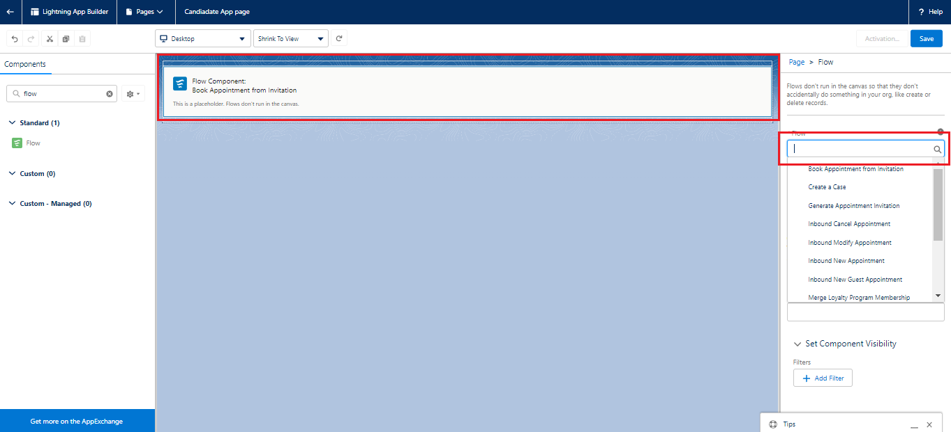  
9. After clicking on the activate it will open a page and then select the lightning experience and select the app and then click on add page to the app.



**Field Update Using Trigger**

Whenever a internal Marks is inserted if the marks is greater than or equal to 200 it must update the status field to Pass or else it must update to fail

1. Go to the gear icon and select the developer console.

2. From the menu bar click on file and select Apex class.

3. Now give the class name as InternalmarksHandler

4. Now Write the  below code

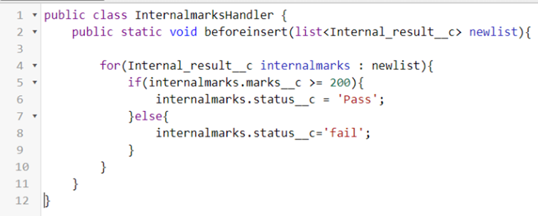

public class InternalmarksHandler {

    public static void beforeinsert(list<Internal_result__c> newlist){

        for(Internal_result__c internalmarks : newlist){

            if(internalmarks.marks__c >= 200){

                internalmarks.status__c = 'Pass';

            }else{

                internalmarks.status__c='fail';

            }

        }

    }

}

5. From the menu bar click on file and select Apex trigger.

6. Now give the trigger name as Internalmarks

7. Now write the below code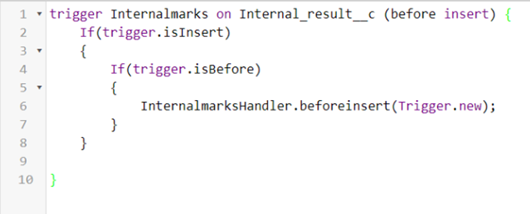

trigger Internalmarks on Internal_result__c(before insert,after update) {

    If(trigger.isInsert)

    {

        If(trigger.isBefore)

        {

            InternalmarksHandler.beforeinsert(Trigger.new);

        }

    }

}

8.Trigger Working as follows:  
   In the following record Marks field is given as 300,Now trigger triggers and  
   status changes to Pass